A

PROJECT REPORT

ON

“**Panic Alarm Circuit**”

Submitted by

Student 1 (Seat No. :[S190343135] Sakshi shirake)

Student 2 (Seat No. : [S190343137] Shweta Shivale)

Student3 (Seat No. : [S190343138] Shruti Singh)

Student 4 (Seat No. : [S190343143]Namrata Totawar )

Student 5 (Seat No. : [S190343144]Ruchita Uttekar)

Student 6 (Seat No:[S190343150] Bhagyashri Zende)

Under the Guidance of

**Prof. V. S. Karambelkar**

**DEPARTMENT OF ELECTRONICS AND TELECOMMUNICATION ENGINEERING**

**BHARATI VIDYAPEETH’S COLLEGE OF ENGINEERING FOR**

**WOMEN, PUNE-43**

**SAVITRIBAI PHULE PUNE UNIVERSITY , PUNE**

**YEAR 2020-21**

**CERTIFICATE**

This is to certify that the SE Project report of

**“Panic Alarm Circuit”**

Submitted by,

Student 1 (Seat No. : [S190343135] Sakshi shirake)

Student 2 (Seat No. : [S190343137] Shweta Shivale)

Student3 (Seat No. : [S190343138] Shruti Singh)

Student 4 (Seat No. : [S190343143]Namrata Totawar)

Student 5 (Seat No. : [S190343144]Ruchita Uttekar)

Student 6 (Seat No:[S190343150] Bhagyashri Zende)

Of SE (Electronics & Telecommunication Engineering ) is a bonafide work carried out by them under the guidance of **Prof. V. S. Karambelkar** and it is approved for the partial fulfillment of the requirement of Savitribai Phule Pune University of **Engineering** in **Electronics & Telecommunication Engineering** at Bharati Vidyapeeth’s College of Engineering for Women , Dhankawadi , Pune-43

**Guide Name Prof. V.S. Karambelkar**

**Guide H.O.D E&TC**

**Place:**

**Date:**

**ACKNOWLEDGEMENGTS**

On the submission of our Project report on “**Panic Alarm Circuit**”, we would like to extend our gratitude and sincere thanks to our HOD **Prof. Dr. S. R. Patil** and guide **Prof. V. S. Karambelkar**, Department of **Electronics and Telecommunication** **Engineering** for their constant motivation and support during the course of our work . We truly appreciate and value their esteemed guidance and encouragement from the beginning. We are indebted for having helped us shape the problem and providing insights towards the solution. And for providing a solid background for our studies and research thereafter. Our guide has been a great source of inspiration to us and we thank her from the bottom of our heart. Above all, we would like to thank all our friends whose direct and indirect support helped us.

Student 1 (Seat No. : [S190343135] Sakshi shirake)

Student 2 (Seat No. : [S190343137] Shweta Shivale)

Student3 (Seat No. : [S190343138] Shruti Singh)

Student 4 (Seat No. : [S190343143]Namrata Totawar)

Student 5 (Seat No. : [S190343144]Ruchita Uttekar)

Student 6 (Seat No:[S190343150] Bhagyashri Zende)

**INDEX**

CERTIFICATE………………………………………………………………………….…

ACKNOWLEDGEMENT ………………………………………………………….…….

LIST OF FIGURES…………………………………………………………………….….

ABSTRACT…………………………………………………………………………….…

1. INTRODUCTION……………………………………………………………………....

2. LITERATURE SURVEY

3. PROBLEM STATEMENT……………………………………………………………..

4. OBJECTIVE…………………………………………………………………………...

5. SPECIFICATIONS ………………………………………………………….….

6. METHODOLGY…………………………………………………………………….....

7. BLOCK DIAGRAM OF SYSTEM …………………………………………………….

8. FLOW CHART AND ALGORITHMS…………………………………………..…….

9. RESULTS........................................................................................................................

10. CONCLUSION…………………………………………………………………………

11. FUTURE SCOPE……………………………………………………………………....

12. REFERENCES…………………………………………………………………………

**ABSTRACT**

This paper presents the design and construction of a panic button alarm system for security emergencies which is used for real time monitoring of security emergencies such as theft, threat to life and property. The main objective of this project is to provide real time monitoring of different security emergency events and to provide location of distressed individuals through GPS mapping system using Google map. This project is achieved using ArduinoUno microcontroller which acts as the brain of the system where all instructions are carried out, Wi-Fi module which gives Wi-Fi access to the microcontroller and the security control centre , GPS module which gives location of push button when triggered by an individual in a threatening situation. This design saves time to contact security in times of security emergencies and can be deployed in rural areas where access to security is limited. Keywords- WiFi Module, GPS, Google Maps, Arduino uno, Microcontroller, Alarm System, Panic Button.

**INTRODUCTION**

A well coordinated security system gives security personnel timely alert for action to be taken to save life and property from destruction. Security systems should be built and placed at strategic locations which should be connected to a central security control centre where the location of a triggered push button is displayed on a google map screen using GPS monitoring system. The security system built can be deployed in rural areas where we have less security personnel. This system is utilized as a lowcost security system which is installed in various locations ranging from market places, stalls, supermarkets, street corners. This paper presents a panic button alarm system for security emergencies, the system is basically made up of an ArduinoUno microcontroller.

The development of the system starts from the design stage of the system where instructions are programmed in a sequential manner. The system starts from the ON state to the activation state to the state where readings are taken from the GPS module to the state where location is sent by the Arduino through the Wi-Fi module.

. **LITERATURE SURVEY**

Unfortunately, crime rates around the world increase every year. In particular, robberies in the streets are the events with the highest rate of occurrence. In addition, these types of events are not notified in a timely manner to the authorities. Therefore, actions can not be carried out adequately. With the aim of contributing to this type of incidents can be notified to the authorities in a timely manner, the present document details the design and implementation of a prototype for a panic alert system. Specifically, a server activated vigilance is designed and a smartphone application is implemented in order to report the theft events. In particular, the notification is sent to two different servers. The person in distress sends the notification when press the lock/power button on the smartphone a certain number of times. The button activates a cluster of video cameras that share live feed to officials in both entities.

**PROBLEM STATEMENT**

* To implement panic alarm circuit using 555IC
* **OBJECTIVE**

A Panic Alarm Circuit is used to send an emergency signal immediately to the people in nearby location to call for help or to alert them. The possible panic situation can be any, it is not restricted to few situations.

One could possibly keep the push button at a hand reachable distance or comfortable place it to carry out quick action in silence by pressing a single button. The indication of emergency can either be in the form of visible or audible signal, which can be fixed at a few meters away through wire.

* **SPECIFICATIONS**

This circuit is made with a low cost hardware using IC 555 timer, buzzer, a few resistors and capacitors. It is made to be working reliably as it has simple to use and not so sensitive hardware like 555 timer, ceramic buzzer, capacitors, etc.

Although no exclusive arrangement is used to make any compensation for the variable parameters, the circuit by default is made to be robust and easy to use. It is very user friendly with a single button to be pressed to handle the panicking situation without any trouble.

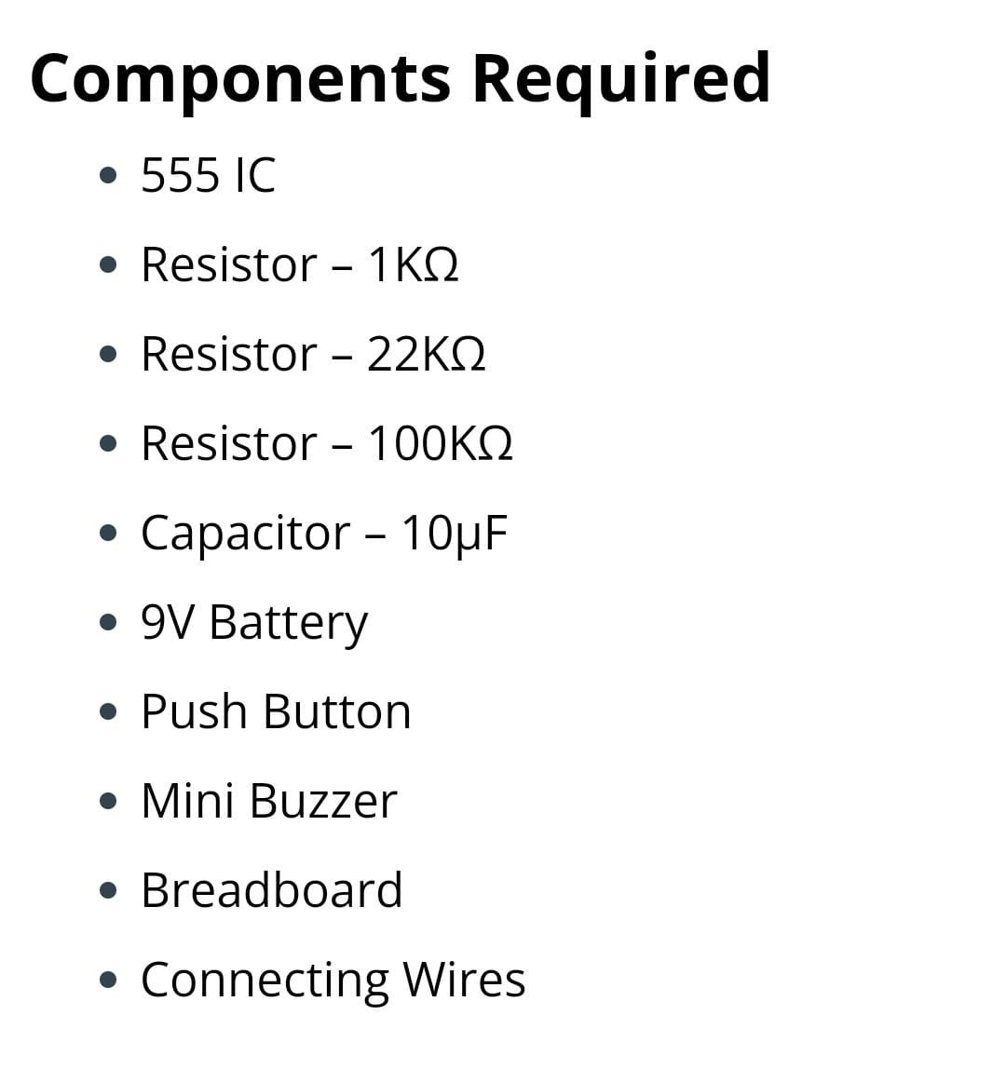

**METHODOLOGY**

The IC 555 is used in the Astable mode with the frequency depending on the values of resistors R2, R3 and C2. The values of R2 = 100KΩ, R3 = 22KΩ and C2 = 10µF.

By substituting the given parameters in the respective formulas for IC 555 in astable mode, we get the following values. The frequency of operation of the circuit is calculated to be 1 Hz. By finding the time period of the circuit by using the frequency information, we get the time period of the circuit as 1 second. This means the circuit has a on -off repeating time period of about 1 second.

After analyzing the ON and OFF time period of the panic alarm circuit given above, we find that the circuit will remain on for about 0.845 seconds and off for about 0.152 seconds.

The circuit is in the disabled mode when the button is not pressed and hence the alarm will not function when the button is not pressed. Although the power supply will be supplied to the IC 555 all the time, the circuit will operate in the astable mode only when the IC is enabled. The IC is in the enable mode only when pin 4 of the 555 IC is given a high voltage.

This happens only when the button is pressed. The button can be made to have a plastic enclosure to have a better visibility and ease of access to it. For the purpose of demonstration, I have connected a simple Buzzer to the output of the 555 IC.

**Circuit Diagram**

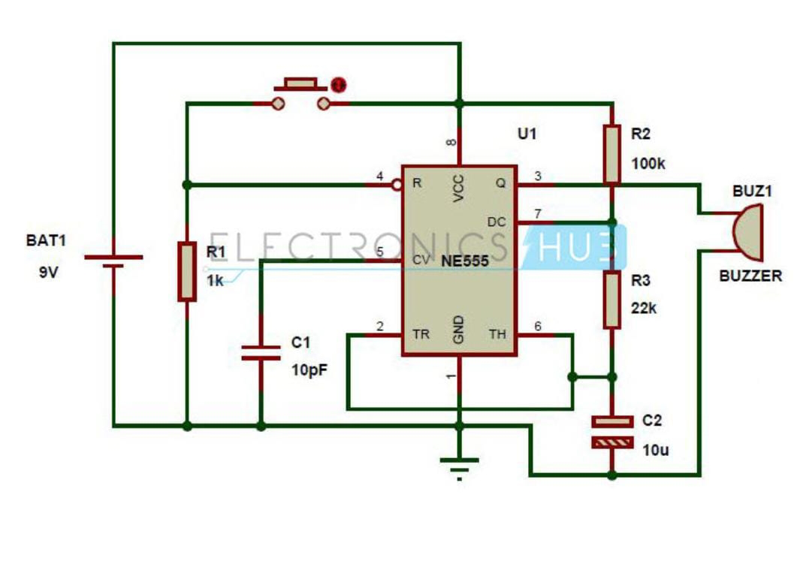

**Flowchart**

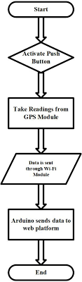

**Block diagram**

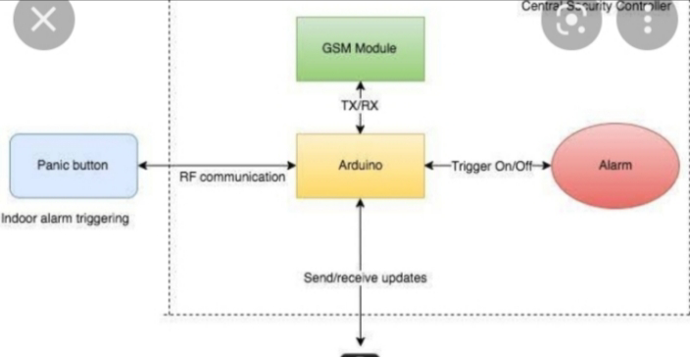

**FUTURE SCOPE**

Panic buttons have for many years been widely used for a range of security risks across a variety of industries. From protecting lone and vulnerable workers to acting as vital elements of a dynamic lockdown procedure, these buttons are designed to summon instant help in emergency situations. They can literally prevent a minor incident turning into a serious one. Traditionally, panic buttons are fixed devices linked either to monitoring stations or the emergency services. But, since the advent of smart security, the functionality, flexibility and mobility of panic buttons has become much enhanced. Now these buttons are packed with flexible features capable of protecting anyone under threat of violence or intimidation, wherever they may be, using the fastest and most effective methods. Let’s take a look at what today’s smart panic buttons have to offer.

**REFERENCES**

* <https://www.communityresponsesystems.com/blog/panic-alarm/>
* Research Gate
* Academia.edu